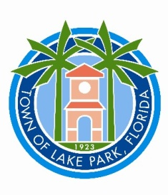**PUBLIC NOTICE**

**TOWN OF LAKE PARK**

**Tree Board Meeting**

**Tuesday, September 10, 2024, 6:00 PM**

**Town Hall Commission Chamber,**

**535 Park Avenue, Lake Park, Florida 33403**

All interested persons are hereby advised that the Town of Lake Park Tree Board will have a meeting on Tuesday, September 10, 2024, 6:00 p.m. The meeting will take place in the Town Hall Commission Chamber, Town of Lake Park, 535 Park Avenue, Lake Park, Florida 33403.

Notice pursuant to Section 286.0105, Florida Statutes, if applicable, is hereby incorporated by reference.

___________________________

**Laura Weidgans**

**Deputy Town Clerk**

**In accordance with the Americans with Disabilities Act of 1990, all persons who are disabled and who need special accommodations to participate in this meeting because of that disability should contact the office of the Town Clerk at 561-881-3311.**

**Anyone wishing to appeal any decision made by the Lake Park Tree Board with respect to any matter considered at such meeting or hearing will need a record of the proceedings and, for such purpose, may need to ensure that a verbatim record of the proceeding is made, which record includes the testimony and evidence upon which the appeal is to be based.**

**One or more Town Commissioners and/or Board members may be present at this meeting.**

**Posted: August 26, 2024**