In May of 2022, the Florida Legislature passed, and the Governor signed into law Senate Bill 4D which requires inspections on condominium buildings three stories or taller. This passage created Florida Statute § 553.899, which details the requirements for compliance for condominium associations and local Building Official.  
  
**Frequently Asked Questions** *(Click on each question to learn more or scroll down to see all answers.)*  
  
• Who is responsible for complying?

• What buildings are required to be inspected?

• What inspection(s) are required?

• What is determined by the inspection(s)?

• When does the inspection have to be performed?

• Who can perform the milestone inspection?

• Who is responsible for the cost of the milestone inspection?

• Will an association be advised when a milestone inspection should occur?

• Once notice is received, how long does a building have to comply?

• What should the association do once the milestone inspection report is completed?

• What happens if inspection(s) are not completed and repairs are not made within the specified timelines?

**Who is responsible for complying?**The Condominium Association or the Cooperative Association overseeing the building is required to comply with the inspection requirement. The condominium or cooperative association may delegate the responsibility for the completion of the inspections to their association manager or management company(ies) contractually. Still, ultimately it is the responsibility of the association to meet the inspection requirements.  
  
  
**What buildings are required to be inspected?**All condominium or cooperative buildings in the State of Florida that are three stories (floors) or greater.**What inspection(s) are required?**The initial required inspection is a Milestone Structural Inspection Phase 1 Inspection. This inspection is a visual inspection of habitable and non-habitable areas of the building. If the Phase 1 inspection has no findings of structural deterioration, then the Phase 2 inspection is not required.  
  
A finding of structural deterioration necessitates the need for a Phase 2 inspection. The Phase 2 inspection involves destructive or non-destructive structural testing at the discretion of the inspector.  
  
  
**What is determined by the inspection(s)?**The inspection(s) must determine the general structural condition of the building as it affects the safety of the building, such as necessary maintenance, repairs, and replacements of structural components.  
  
The inspection(s) must also assess for substantial structural deterioration. “Substantial structural deterioration” is described as substantial structural distress that negatively affects the building’s general structural condition and integrity.  
  
  
**When does the inspection have to be performed?**Milestone inspections must be performed by December 31 of the year the building reaches 30 years in age, based on the issue date of the building’s certificate of occupancy, and every 10 years thereafter.  
  
Buildings with a certificate of occupancy issued on or before July 1, 1992, must have the initial milestone inspection performed before December 31, 2024.  
  
Buildings within three miles of the coastline must perform a milestone inspection by December 31 of the year they reach 25 years in age and every ten years after that. A portion of the buildings within the Town of Lake Park East of 13th Street are located within three miles of the coastline and thus will have to comply with the 25-year requirement and the other portions West of 13th Street will need to meet the 30-year requirement.

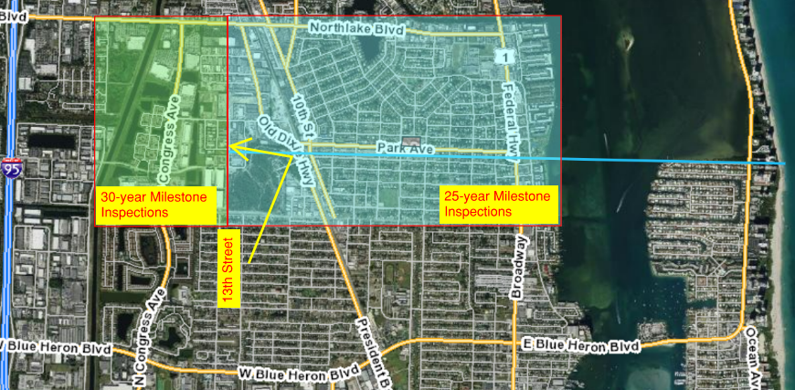  
  
Milestone inspection(s) must also be performed every ten years following the initial inspection.  
  
  
**Who can perform the milestone inspection?**Milestone inspections must be performed by a Florida licensed engineer or registered architect who is qualified to determine the life safety attributes and adequacy of structural components of the building.  
  
  
**Who is responsible for the cost of the milestone inspection?**Condominium and cooperative associations are responsible for the scheduling and costs associated with the milestone inspection.  
  
  
**Will an association be advised when a milestone inspection should occur?**The statute requires that the local building official provide notice by certified mail to all associations whose buildings are required to comply with this law. You will receive this official notice approximately 180 days prior to your milestone inspection due date if you have not already submitted the inspection results to the local building official.  
  
  
**Once notice is received, how long does a building have to comply?**Upon receiving official notice (by certified mail), condominium/cooperative associations will have 180 days to complete phase one of the inspection.  
  
  
**What should the association do once the milestone inspection report is completed?**The architect or engineer who performed inspections must submit a sealed copy of the inspection report and findings to the association and appropriate local building official.  
  
Once the association receives the report, it is required to distribute the inspector-prepared report summary to each unit owner, post a copy in a conspicuous place on the property, and publish the summary and full report on the association’s website.  
  
The association must commence repairs for substantial structural deterioration within 365 days of receipt of the Phase 2 inspection report.  
  
  
**What happens if inspection(s) are not completed, and repairs are not made within the specified timelines?**Associations that fail to complete the mandatory Milestone Inspection will breach the officers’ and/or directors’ fiduciary relationship to the unit owners.  
  
Failure to complete the inspections or repairs within the specified timeframe will result in penalties to the association up to and including potential liens on the building.  
  
Additionally, failure to commence substantial structural deterioration repairs within the specified timeframes will result in the Building Official reviewing and determining whether the building is unsafe for human occupancy.