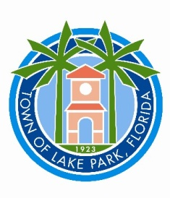**PUBLIC NOTICE**

**TOWN OF LAKE PARK**

**Joint Planning & Zoning Board**

**Meeting with Village of North Palm Beach**

**Planning, Zoning and Adjustment Board and**

**Town of Lake Park Planning and Zoning Board**

**Monday, January 8, 2024 at 6:00 pm**

**North Palm Beach Village Hall Council Chambers**

**420 US Highway 1, Suite 21 North Palm Beach, FL**

All interested persons are hereby advised that the Town of Lake Planning and Zoning Board will have a joint meeting with the Village of North Palm Beach Planning, Zoning and Adjustment Board on Monday, January 8, 2024 at 6:00 pm. The meeting will take place in the North Palm Beach Village Hall Council Chambers, Village of North Palm Beach, 420 US Highway 1, Suite 21, North Palm Beach, FL.

Notice pursuant to Section 286.0105, Florida Statutes, if applicable, is hereby incorporated by reference.

**________________________**

**Laura Weidgans**

**Deputy Town Clerk**

In accordance with the Americans with Disabilities Act of 1990, all persons who are disabled and who need special accommodations to participate in this meeting because of that disability should contact the office of the Town Clerk at 561-881-3311.

Anyone wishing to appeal any decision made by the Historic Preservation Board with respect to any matter considered at such meeting or hearing will need a record of the proceedings and, for such purpose, may need to ensure that a verbatim record of the proceeding is made, which record includes the testimony and evidence upon which the appeal is to be based.

One or more Town Commissioners and/or Board members may be present at this meeting.

Posted on: December 22, 2023